Student’s name | …………………………………………………….…… | Grade | 3
Subject | Computer | Week No. | 12
Lesson Title | Spreadsheet | Unit
Worksheet No. ( 12 ) (Answer)

Question A: Write the correct name of each part.

Excel Logo | Spreadsheet

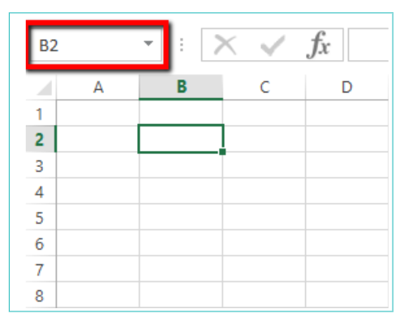
Spreadsheet
Excel Logo
Good Luck

